Adaptive Median Filtering
Seminar Report
By: PENG Lei (ID: 03090345)

ABSTRACT
The application of median filter has been investigated. As an advanced method compared with standard median filtering, the Adaptive Median Filter performs spatial processing to preserve detail and smooth non-impulsive noise. A prime benefit to this adaptive approach to median filtering is that repeated applications of this Adaptive Median Filter do not erode away edges or other small structure in the image.

KEY WOEDS
Digital image processing, Pixel, Neighborhood, Median filter, Mean filter (average filter), Linear & non-linear filter, Image smoothing, Image enhancement, Impulse noise (salt & pepper noise)

The basic operation of digital image processing

To understand what adaptive median filtering is all about, one first needs to understand what a median filter is and what it does. In many different kinds of digital image processing, the basic operation is as follows: at each pixel in a digital image we place a neighborhood
around that point, analyze the values of all the pixels in the neighborhood according to some algorithm, and then replace the original pixel's value with one based on the analysis performed on the pixels in the neighborhood
. The neighborhood
then moves successively over every pixel in the image, repeating the process.

What a median filter is and what it does?

Median filtering follows this basic prescription. The median filter is normally used to reduce noise in an image, somewhat like the mean filter. However, it often does a better job than the mean filter of preserving useful detail in the image. This class of filter belongs to the class of edge preserving smoothing filters which are non-linear filters. This means that for two images A(x) and B(x):
These filters smooths the data while keeping the small and sharp details. The median is just the middle value of all the values of the pixels in the neighborhood. Note that this is not the same as the average (or mean); instead, the median has half the values in the neighborhood larger and half smaller. The median is a stronger "central indicator" than the average. In particular, the median is hardly affected by a small number of discrepant values among the pixels in the neighborhood. Consequently, median filtering is very effective at removing various kinds of noise. Figure 1 illustrates an example of median filtering.

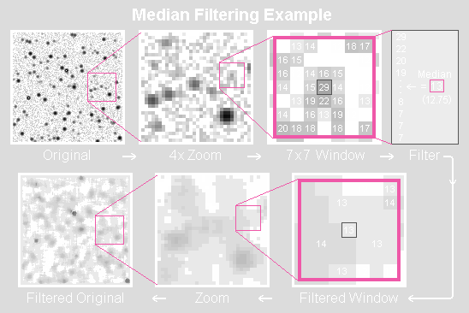
Figure 1

Like the mean filter, the median filter considers each pixel in the image in turn and looks at its nearby neighbors to decide whether or not it is representative of its surroundings. Instead of simply replacing the pixel value with the mean of neighboring pixel values, it replaces it with the median of those values. The median is calculated by first sorting all the pixel values from the surrounding neighborhood into numerical order and then replacing the pixel being considered with the middle pixel value. (If the neighborhood under consideration contains an even number of pixels, the average of the two middle pixel values is used.) Figure 2 illustrates an example calculation.

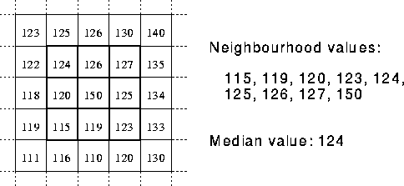
Figure 2 Calculating the median value of a pixel neighborhood. As can be seen, the central pixel value of 150 is rather unrepresentative of the surrounding pixels and is replaced with the median value: 124. A 3×3 square neighborhood is used here --- larger neighborhoods will produce more severe smoothing.

What is noise?
Noise is any undesirable signal. Noise is everywhere and thus we have to learn to live with it. Noise gets introduced into the data via any electrical system used for storage, transmission, and/or processing. In addition, nature will always plays a "noisy" trick or two with the data under observation. When encountering an image corrupted with noise you will want to improve its appearance for a specific application. The techniques applied are application-oriented. Also, the different procedures are related to the types of noise introduced to the image. Some examples of noise are: Gaussian or White, Rayleigh, Shot or Impulse, periodic, sinusoidal or coherent, uncorrelated, and granular.

Noise Models
Noise can be characterized by its:
Probability density function (pdf): Gaussian, uniform, Poisson, etc.
Spatial properties: correlation
Frequency properties: white noise vs pink noise

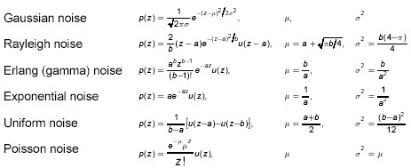

Figure 3 Original Image

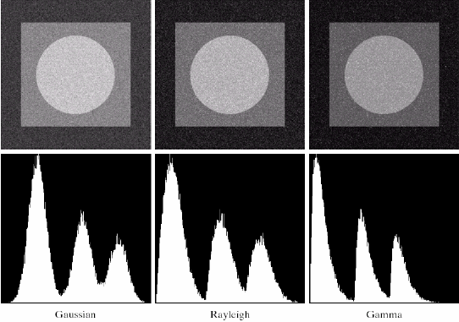
Figure 4 Images and histograms resulting from adding Gaussian, Rayleigh and Gamma noise to the original image.

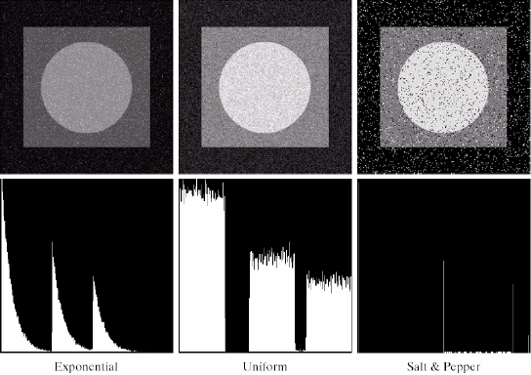
Figure 4 (continued) Images and histograms resulting from adding Exponential, Uniform and Salt & Pepper noise to the original image.

Comparison between the median filter and the average filter

Sometimes we are confused by median filter and average filter, thus let’s do some comparison between them. The median filter is a non-linear tool, while the average filter is a linear one.
In smooth, uniform areas of the image, the median and the average will differ by very little. The median filter removes noise, while the average filter just spreads it around evenly. The performance of median filter is particularly better for removing impulse noise than average filter.

As Figure 5 shown below are the original image and the same image after it has been corrupted by impulse noise at 10%. This means that 10% of its pixels were replaced by full white pixels. Also shown are the median filtering results using 3x3 and 5x5 windows; three (3) iterations of 3x3 median filter applied to the noisy image; and finally for comparison, the result when applying a 5x5 mean filter to the noisy image.

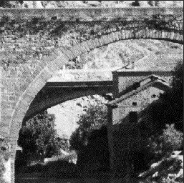 | 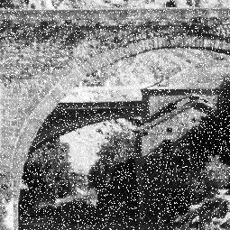
a)Original image; b)Added Impulse Noisy at 10%

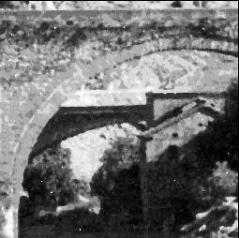 | 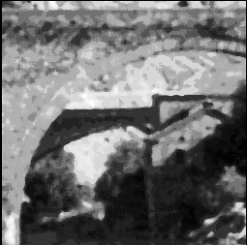
a)3x3 Median Filtered; b)5x5 Median Filtered
Comparison of the non-linear Median filter and the linear Mean filter.
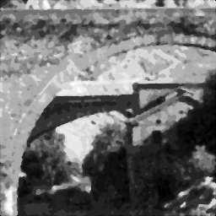 | 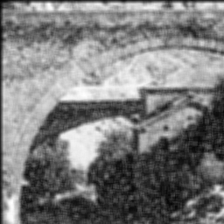
a)3x3 Median Filtered applied 3 times; b)5x5 Average Filter
Figure 5

The disadvantage of the median filter
Although median filter is a useful non-linear image smoothing and enhancement technique. It also has some disadvantages. The median filter removes both the noise and the fine detail since it can't tell the difference between the two. Anything relatively small in size compared to the size of the neighborhood will have minimal affect on the value of the median, and will be filtered out. In other words, the median filter can't distinguish fine detail from noise.

Adaptive Median Filtering

Therefore the adaptive median filtering has been applied widely as an advanced method compared with standard median filtering. The Adaptive Median Filter performs spatial processing to determine which pixels in an image have been affected by impulse noise. The Adaptive Median Filter classifies pixels as noise by comparing each pixel in the image to its surrounding neighbor pixels. The size of the neighborhood is adjustable, as well as the threshold for the comparison. A pixel that is different from a majority of its neighbors, as well as being not structurally aligned with those pixels to which it is similar, is labeled as impulse noise. These noise pixels are then replaced by the median pixel value of the pixels in the neighborhood that have passed the noise labeling test.

Purpose
1). Remove impulse noise
2). Smoothing of other noise
3). Reduce distortion, like excessive thinning or thickening of object boundaries

How it works?
● Adaptive median filter changes size of Sxy (the size of the neighborhood) during operation.

● Notation
Zmin = minimum gray level value in Sxy
Zmax = maximum gray level value in Sxy
Zmed = median of gray levels in Sxy
Zxy = gray level at coordinates (x, y)
Smax = maximum allowed size of Sxy

● Algorithm
Level A: A1 = Zmed - Zmin
A2 = Zmed - Zmax
if A1 > 0 AND A2 < 0, go to level B
else increase the window size
if window size < Smax, repeat level A
else output Zxy
Level B: B1 = Zxy - Zmin
B2 = Zxy - Zmax
if B1 > 0 AND B2 < 0, output Zxy
else output Zmed

● Explanation
Level A: IF Zmin < Zmed < Zmax, then
• Zmed is not an impulse
(1) go to level B to test if Zxy is an impulse ...
ELSE
• Zmed is an impulse
(1) the size of the window is increased and
(2) level A is repeated until ...
(a) Zmed is not an impulse and go to level B or
(b) Smax reached: output is Zxy
Level B: IF Zmin < Zxy < Zmax, then
• Zxy is not an impulse
(1) output is Zxy (distortion reduced)
ELSE
• either Zxy = Zmin or Zxy = Zmax
(2) output is Zmed (standard median filter)
• Zmed is not an impulse (from level A)

Advantages
The standard median filter does not perform well when impulse noise is
- Greater than 0.2, while the adaptive median filter can better handle these noises.
- The adaptive median filter preserves detail and smooth non-impulsive noise, while the standard median filter does not.

See example form a) to d)
in figure 6.

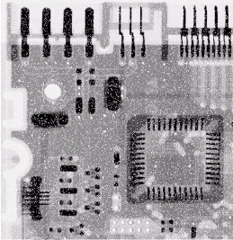
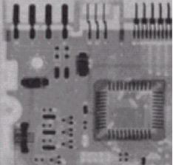
- Image corrupted by impulse noise b) Result of arithmetic mean filtering;

with a probability of 0.1;
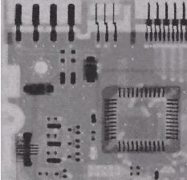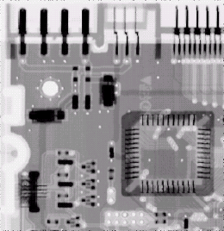

c) Result of adaptive median filtering; d) Result of standard median filtering
Figure 6

Conclusion:
The median filter performs well as long as the spatial density of the impulse noise is not large. However the adaptive median filtering can handle impulse noise with probabilities even larger than these. An additional benefit of the adaptive median filter is that it seeks to preserve detail while smoothing nonimpulse noise. Considering the high level of noise, the adaptive algorithm performed quite well. The choice of maximum allowed window size depends on the application, but a reasonable starting value can be estimated by experimenting with various sizes of the standard median filter first. This will establish a visual baseline regarding expectations on the performance of the adaptive algorithm.

References
[1] Rafael C. Gonzalez and Richard E. Woods Digital Image Processing, 2001, pp.220 – 243.
[2] R. Boyle and R. Thomas Computer Vision: A First Course, Blackwell Scientific Publications, 1988, pp. 32 - 34.
[3] E. Davies Machine Vision: Theory, Algorithms and Practicalities, Academic Press, 1990, Chap. 3.
[4] A. Marion An Introduction to Image Processing, Chapman and Hall, 1991, pp. 274.
[5] D. Vernon Machine Vision, Prentice-Hall, 1991, Chap. 4.
[6] J. Chen, A. K. Jain, "A Structural Approach to Identify Defects on Textural Images", Proceedings of the IEEE International Conference on Systems, Man, and Cybernetics, pp. 29-32, Beijing, 1988.

[7] H.Moro, T.Watanabe, A.Taguchi and N. Hamada, "On the adaptive algorithm and its convergence rate improvement of 2-Dlattice filter", 1988 IEEE International Symposium on Circuits and Systems, Proceeding vol. 1 of 3, pp. 430-434.

[8] R.Meylani, S.Sezen, A. Ertüzün, Y. Istefanopulos, "LMS and Gradient Based Adaptation Algorithms for the Eight-Parameter Two-Dimensional Lattice Filter", Proceedings of the European Conference on Circuit Theory and Design, pp.741-744, 1995.

